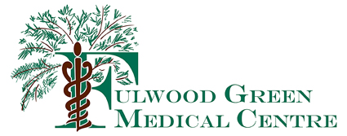

Practice Privacy Policy
Your data, privacy and the Law

How we use your medical records

- This practice handles medical records according to the laws on data protection and confidentiality.

- We share medical records with health professionals who are involved in providing you with care and treatment. This is on a need to know basis and event by event.

- Some of your data is copied to the NHS Shared Care Summary Record if you consent to this.

- We do share some of your data with local out of hours / urgent or emergency care service

- Data about you is used to manage national screening campaigns such as Flu, Cervical cytology and Diabetes prevention.

- Data about you, usually anonymised, is used to manage the NHS and make payments.

- We share information when the law requires us to do, for instance when we are inspected or reporting certain illnesses or safeguarding vulnerable people.

- Your data is used to check the quality of care provided by the NHS.

- We may also share medical records for medical research but we will ask your explicit consent to do this.

- All calls to and from the Practice are recorded for training and monitoring purposes

